D2 Report

Data Structure Similarity

The ContactBook also represents a tree structure. The original ContactBook acts as the root, while each recursed_book created after a collision acts as a child at a deeper level. The depth of the tree corresponds to the character position used to hash the nickname. Nicknames that share the same characters remain on the same path, while different characters place them into different branches. Therefore, the recursive ContactBooks form a hierarchical tree in which nicknames are partially organised according to their characters.

Testing Evidence

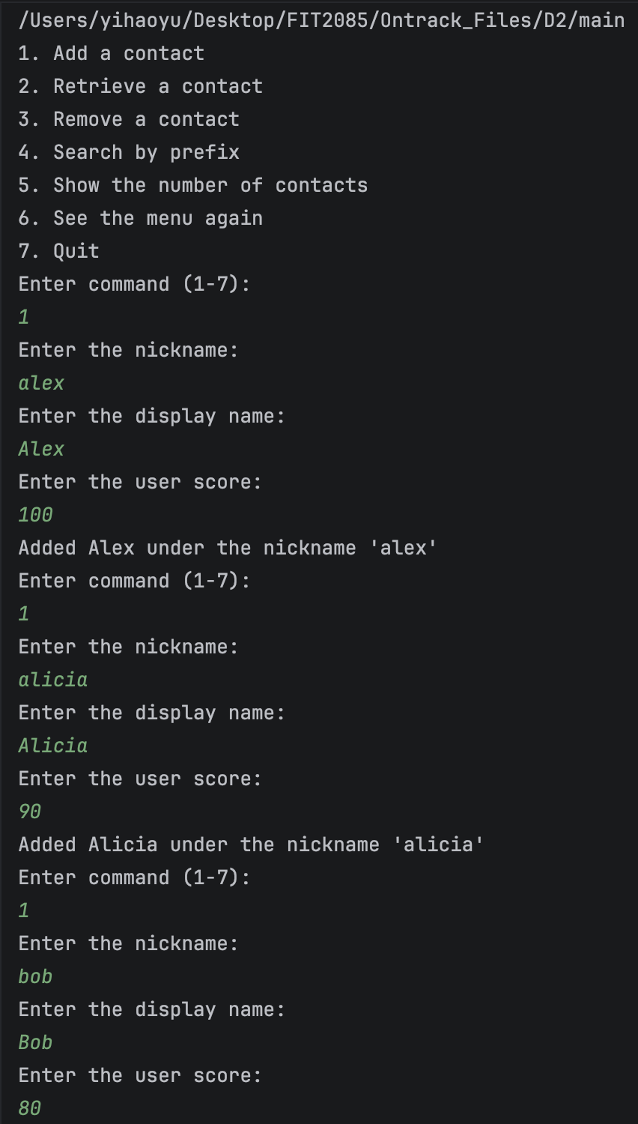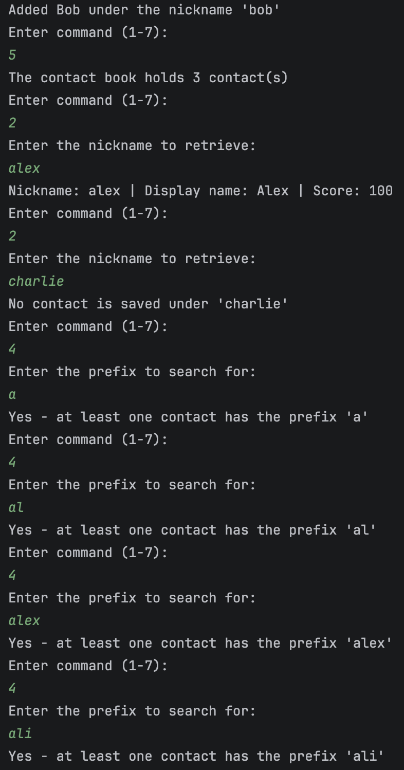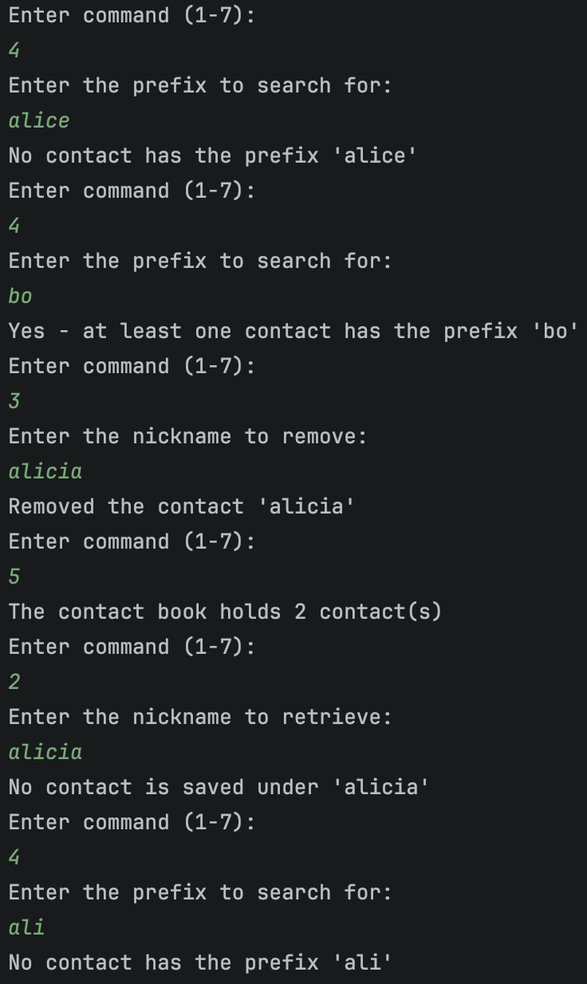

Word Count
93

